TAKE-HOME MATH BOOK BAG

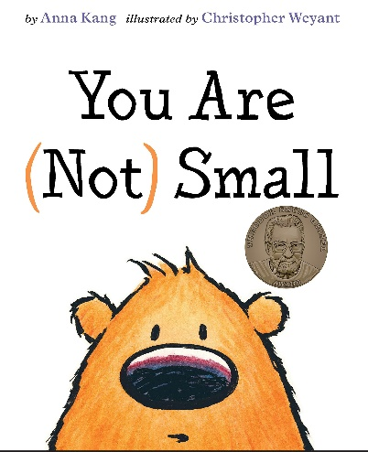

**Discussion Questions:**

• Have you ever felt small?

• What other words can you think of that describe size?

• Why did the creature feel small in the beginning but not at the end of the story?

• How can we measure to find out how big or small something is?

**Activity:**

Use the cut-out of the creature from the book to find some examples of things around the house that are bigger and smaller than the creature. You can say, “This __ is bigger than the creature.” Or “This __ is smaller than the creature.”

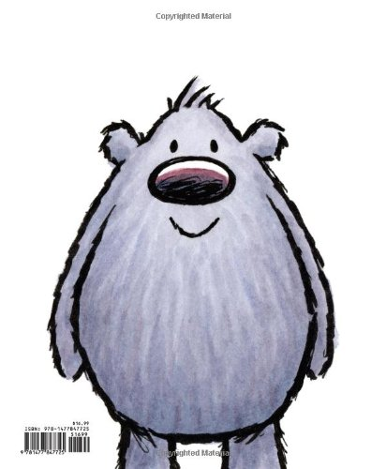TAKE-HOME MATH BOOK BAG

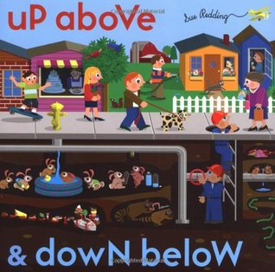

**Discussion Questions:**

• Have you ever thought about what is up above or down below?

• What other words can you think of that show position?

• Why is it important to use words that show where things are located?

• Looking around the room, can you use the word *behind* to describe where something is located?

• Looking around the room, can you use the word *between* to describe where something is located?

• Looking around the room, can you use the word *above* to describe where something is located?

**Activity:**

Go on a scavenger hunt to find out what is (a) beside the kitchen sink, (b) under the couch, (c) inside a bathroom drawer, (d) outside the front door, and (e) on top of the refrigerator. Make a list of the things you find in all these spots.

TAKE-HOME MATH BOOK BAG

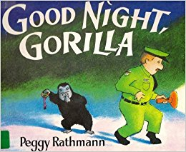

**Discussion Questions:**

• How can you retell the story using the words first, second, third, fourth, and fifth?

• Why do you think the gorilla lets the animals out of their cages?

• What problems does the watchman’s wife have? How does she solve it?

• Which is your favorite page in the book? Why?

• Which animal in the book is the largest? How can you know for sure?

• Which animal in the book is the smallest? How can you tell?

**Activity:**

The hand of a silverback gorilla can be 11 inches long. Use a ruler to draw an outline of a hand 11 inches from wrist to fingertip. Compare the gorilla’s hand size to your own hand.

TAKE-HOME MATH BOOK BAG

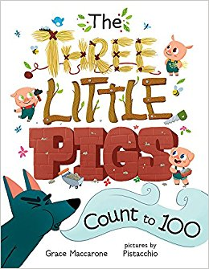

**Discussion Questions:**

• What kind of math do you see in this book?

• Why do you think the author chose to include shapes and numbers?

• What problems do the characters have? How do they solve them?

• Which is your favorite page in the book? Why?

• What strategies can you use to keep track of what’s been counted on each page?

**Activity:**

Design a home for a pig using blocks, Legos®, or cardboard boxes like cereal or mac and cheese boxes. Take a photo, then print it out or email it to teacher.

TAKE-HOME MATH BOOK BAG

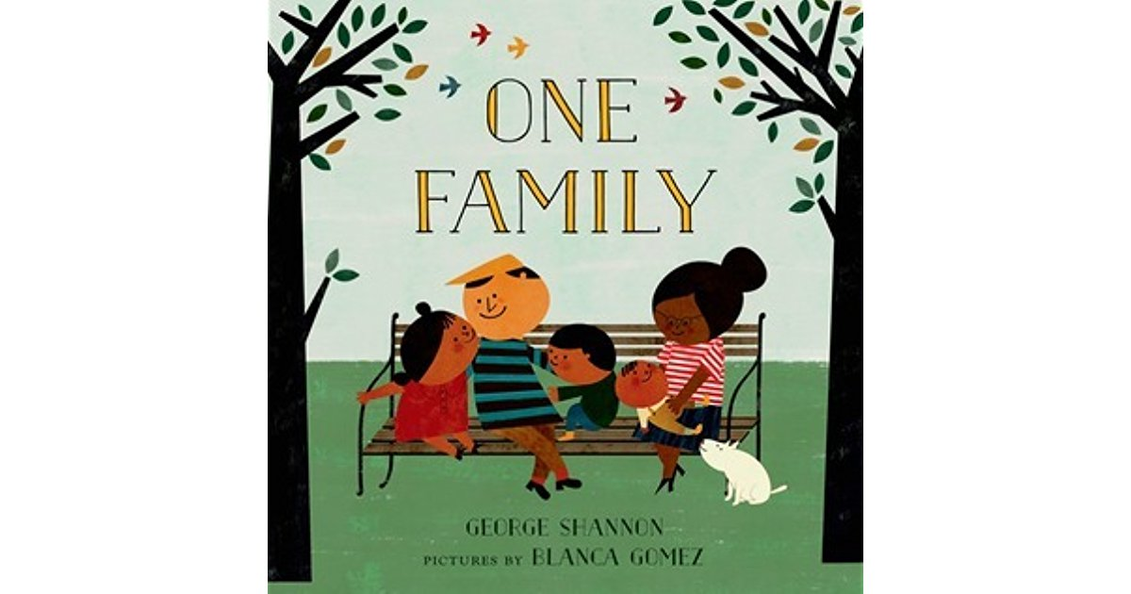

**Discussion Questions:**

• What is this book about?

• How many people are in our family?

• How are the families in this book similar or different from our family?

• What are some things the illustrator could also include on the page for the number two? What things could the illustrator include on the page for the number three?

• Which is your favorite page in the book? Why?

• What strategies can you use to keep track of what’s been counted?

**Activity:**

Draw a picture of your family doing something you enjoy. Write a number sentence that tells about your picture.

TAKE-HOME MATH BOOK BAG 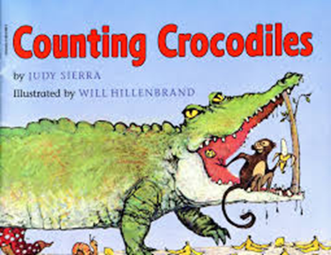

**Discussion Questions:**

• What is this book about?

• What problem does the monkey have?

• How could the monkey keep track of the crocs she has counted?

• If the monkey counted all the crocodiles instead of grouping them, how many crocodiles would she count?

• Which page is your favorite? Why?

• Why do you think the crocodiles want to be counted?

**Activity:**

Draw a new page for the story showing 11 crocodiles. What silly things could the crocs be doing? Number the crocs to be sure you have exactly 11.

TAKE-HOME MATH BOOK BAG

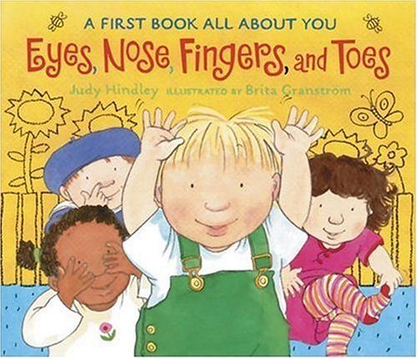

**Discussion Questions:**

• What is your favorite page in this book? Why?

• What parts of your body come in sets of two?

• What parts of your body come in sets of ten?

• What parts of your body come in singles?

• Why is it useful to know you have five fingers on each hand?

**Activity:**

Play *Simon Says* with your family using numbers in the instructions. For example, Simon says clap three times. Stomp your left foot five times. Ah, oh. Simon didn’t say. 😊

TAKE-HOME MATH BOOK BAG

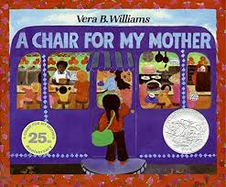

**Discussion Questions:**

• What is this book about?

• What obstacles does the girl have to overcome to earn the money to buy her mother a chair?

• When have you saved your money to buy something?

• How do you think the girl felt at the end of the book?

• Why is it important to save money?

**Activity:**

Play the Coin Trading Game. You’ll need some pennies, nickels, and dimes and a die. Roll the die and take that number of pennies. When you have five pennies, trade them for a nickel. When you have two nickels, trade them for a dime. The first person with five dimes is the winner.

____PENNIES NICKELS DIMES_____

TAKE-HOME MATH BOOK BAG

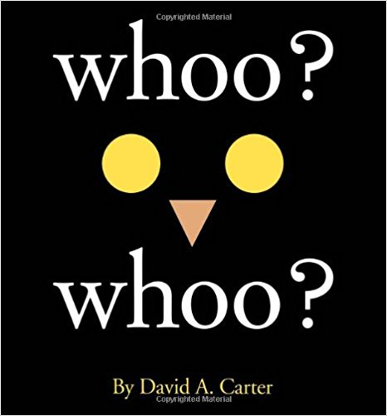

**Discussion Questions:**

• What shapes do you see in this book?

• Did you notice anything surprising about the shapes of the animals in this book?

• What shapes do you see around you right now?

• Which page in this book is your favorite?

• What animals do you wish the author had included, but didn’t?

• Have you ever used shapes to create a new shape or design? Tell about it.

**Activity:**

Use tangrams to create animal shapes.

TAKE-HOME MATH BOOK BAG 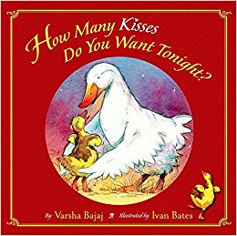

**Discussion Questions:**

• What is this book about?

• Which page is your favorite? Why?

• Which animal wanted the most kisses goodnight?

• Which animal wanted the fewest kisses goodnight?

• What things do you do to get ready for bed at night?

• How many goodnight kisses do you like?

**Activity:**

Everyone in the family puts bright colored lip balm on their lips, kisses an index card, and counts the kisses. How many kisses fit on the card? Who fit the most kisses on their card? Who fit the fewest kisses on their card?